4.42: a) The velocity of the spacecraft is downward. When it is slowing down, the acceleration is upward. When it is speeding up, the acceleration is downward.

b)
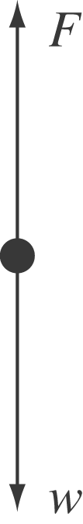 speeding up: 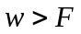 and the net force is downward
slowing down: 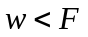 and the net force is upward
c) Denote the y-component of the acceleration when the thrust is 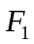 by 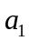 and the y-component of the acceleration when the thrust is 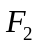 by 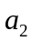. The forces and accelerations are then related by
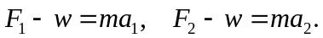
Dividing the first of these by the second to eliminate the mass gives
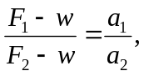
and solving for the weight w gives
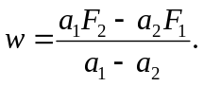
In this form, it does not matter which thrust and acceleration are denoted by 1 and which by 2, and the acceleration due to gravity at the surface of Mercury need not be found. Substituting the given numbers, with 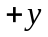 upward, gives

In the above, note that the upward direction is taken to be positive, so that  is negative. Also note that although is known to two places, the sums in both numerator and denominator are known to three places.

